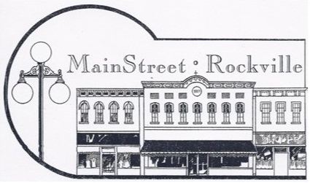
PO Box 334
Rockville, IN 47872

We would like to invite you/your business to be a part of MainStreet Rockville. The MainStreet Rockville is an organization that strives to make Rockville a thriving place to live, work, and maintain a business. As an arm of Indiana MainStreet, we are a team of residents, merchants, and other interested citizens who believe that Rockville, Indiana is a special place to visit, live, work, shop, and stay. Our dedicated, passionate members engage in a variety of activities and host fun community events to spotlight and enhance the many qualities that make Rockville and Parke county a unique and wonderful place.
MainStreet Rockville works diligently to promote its members’ businesses and support our community. We continue to promote our member businesses and support tourism in our community. Our rack card is currently stocked at over a dozen rest-stops through-out the state. We also distribute locator maps representing our community. We continue to share posts and link our members daily through Facebook.
We host many events in the community encourage networking and tourism. We host a Community Yard Sale, Brick Street Market, Cruise-in & Street Dance, Trick or Treat on the Square and the Hometown Holidays. MainStreet Rockville is also responsible for creating the Parke County Hospitality Directory and the Locator Map. Please visit our website at www.mainstreetrockville.org and/or our Facebook page “MainStreet Rockville”
Becoming a member is just one step in joining MainStreet Rockville. We encourage everyone to take an active role by volunteering to be on one of our committees or events. We are always growing and changing! We welcome you to join as many of our MainStreet meetings as you are able, meeting the first Monday of every month, currently at Ivy Tech at 8:15am.
Become a member today for $25.00 and help us make a difference in our community.
__ __ __ __ __ __ __ __ __ __ __ __ __ __ __ __ __ __ __ __ __ __ __ __ __ __ __ __ __ __ __ __ __ __

MAINSTREET ROCKVILLE MEMBERSHIP 2019
Business Name: ________________________________________________________________
Contact: ________________________________________________________________
Individual Name: _______________________________________________________________
Mailing Address: _______________________________________________________________
Physical Address: _______________________________________________________________
Phone: _______________________________________________________________________
Email: ________________________________________________________________________
Please send your $25.00 Membership to: MainStreet Rockville, P.O. Box 334, Rockville, IN 47872
Thank you for your continued support!

